## Rakshitha Devi J

## What are IaaS, PaaS, SaaS?

Cloud computing has three main cloud service models:

[IaaS](https://cloud.google.com/learn/what-is-iaas) (infrastructure as a service), [PaaS](https://cloud.google.com/learn/what-is-paas) (platform as a service), and SaaS (software as a service). You might also hear IaaS, PaaS, and SaaS called cloud service offerings or cloud computing categories, but all of these terms refer to how you use the cloud in your organization and the degree of management you’re responsible for in your cloud environments.

“As a service” typically means that the service model is offered by a third party in the cloud. In other words, you don’t have to purchase, manage, or use any hardware, software, tools, or applications from an on-premises data center. Instead, you can simply pay a subscription or pay based on consumption (pay-as-you-go) to access what you need on demand via an internet connection.

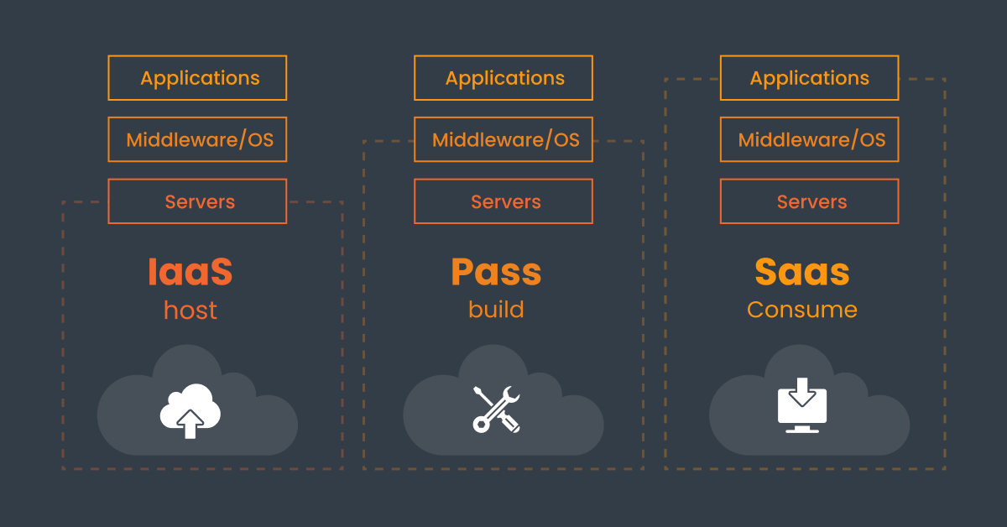

Here’s a basic breakdown of each service model:

## **IaaS**

Infrastructure as a Service ([IaaS](https://www.geeksforgeeks.org/infrastructure-as-a-service-iaas/)) is a cloud service model that provides virtualized computing resources over the internet. It delivers essential infrastructure components such as servers, storage, networking, and computing resources on a pay-as you-go use basis.

Unlike traditional on-premises data centers, IaaS enables businesses to rent physical resources without managing hardware directly. This flexibility allows businesses to scale up or down based on their needs, making it ideal for startups and large enterprises alike.

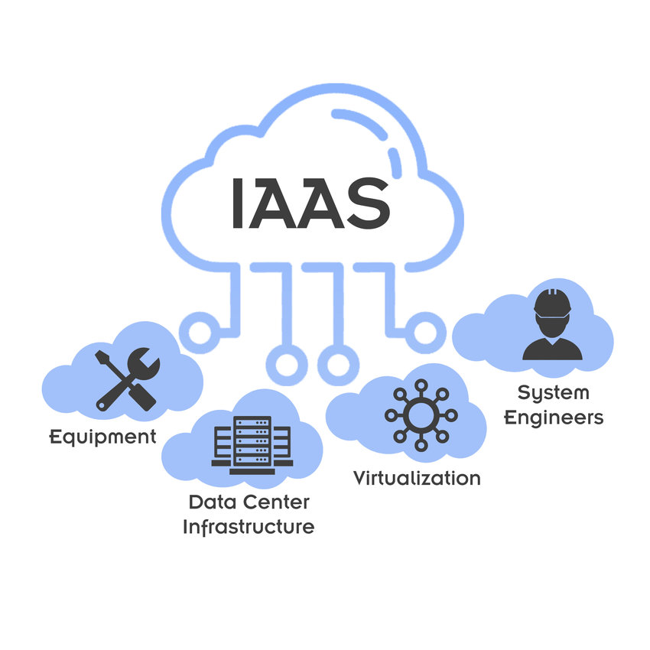

**Real World Use Cases:**

A tech startup might need to scale its infrastructure quickly as traffic spikes. Using IaaS, such as [Amazon Web Services(AWS)](https://www.geeksforgeeks.org/introduction-to-amazon-web-services/) or [Microsoft Azure](https://www.geeksforgeeks.org/what-is-microsoft-azure/), they can easily increase their server capacity without investing in expensive hardware.

## **PaaS**

Platform as a Service ([PaaS](https://www.geeksforgeeks.org/platform-as-a-service-paas-and-its-types/)) offers a cloud environment for developing, running, and managing applications without dealing with the complexities of maintaining the underlying infrastructure. It provides a platform that includes tools for app development, hosting, and runtime management. PaaS is aimed at developers who want to focus on building applications rather than managing hardware or operating system.

PaaS is a great choice for developers building web applications or mobile apps that require backend services like databases, authentication, and messaging. It Simplifies development by automating infrastructure management.

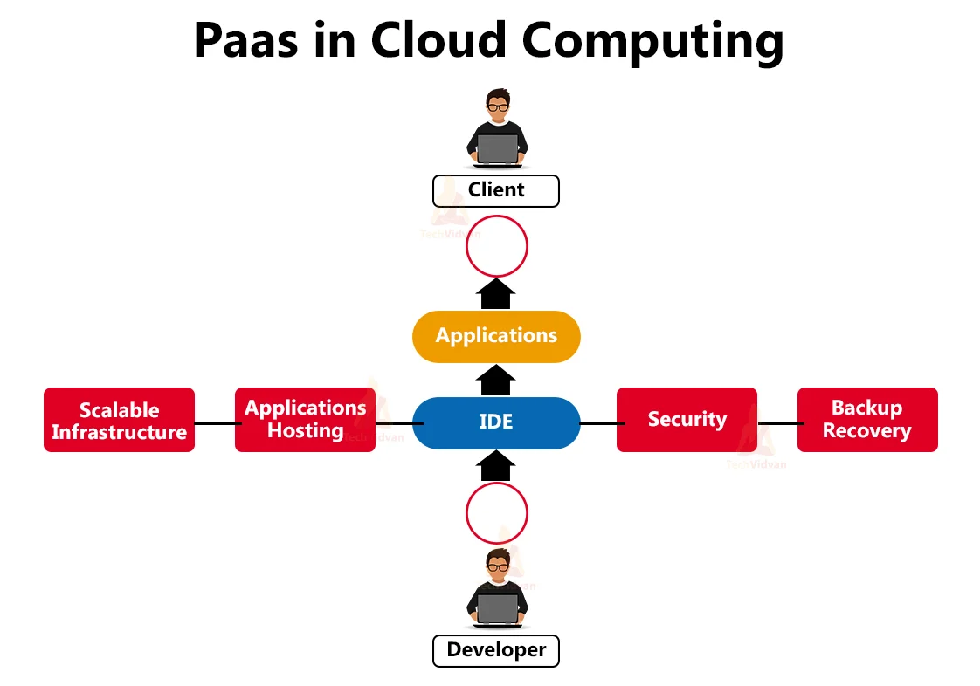

**Real World use Case:**

A software development company building a SaaS product can use Google App Engine or AWS Elastic Beanstalk to deploy their web application without worrying about setting up servers, networking, or storage.

## **SaaS**

Software as a Service ([SaaS](https://www.geeksforgeeks.org/software-as-a-service-saas/)) is the most user-friendly model, providing complete software applications hosted in the cloud. Instead of purchasing and installing software on individual devices, users can access applications over the internet. SaaS eliminates the need for businesses to install, maintain, or manage software themselves.

SaaS is ideal for businesses that needs ready-to-use software for communication or data management. It's highly accessible, making it suitable for end-users who don't have any technical knowledge to operate.

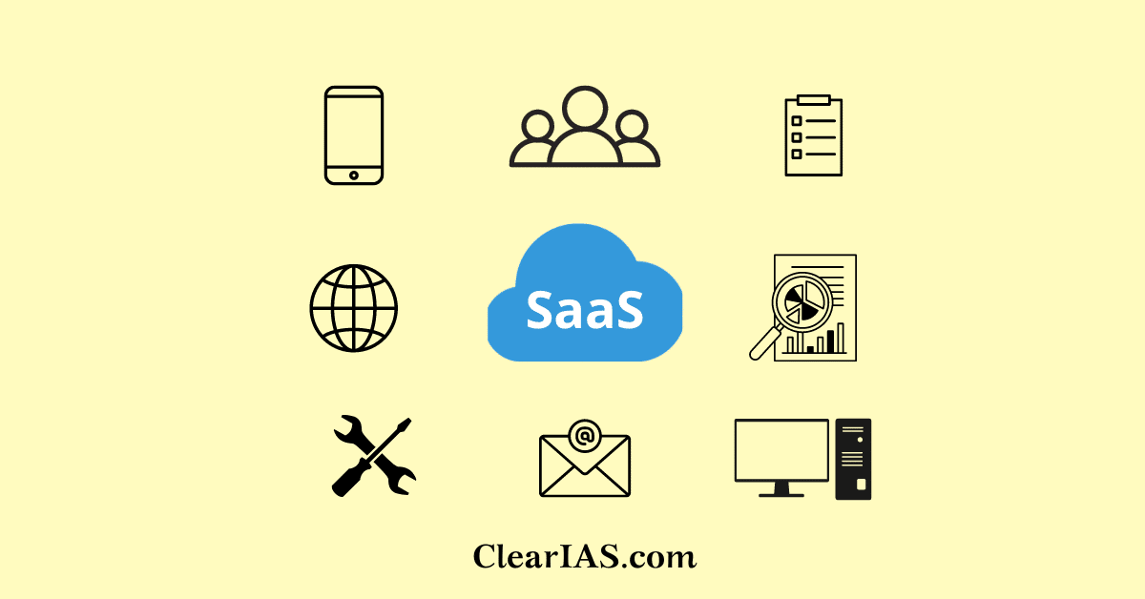

**Real-World Use Cases:**

Companies use **Salesforce** for customer relationship management (CRM), **Microsoft 365** for office productivity tools, and Zoom for communication and meetings. All of these are SaaS products, which require no installation or maintenance by the user.